Daniel Allison

danielallison77@gmail.com

n01465744

Assignment 1

CCGC 5502 Automation – Humber College

Table of Contents

**Phase 1: Development** 4

Setup 4

GitHub Repo 4

Cocogitto 5

backend.tf and providers.tf 6

terraform init 7

Project Metadata (root variables.tf) 8

Resource Group Child Module 9

Definition 9

Dev Test: Validation, Provisioning, Verifying in Azure Portal 10

Release 11

Network Child Module 12

Definition 12

Dev Test: Validation, Provisioning, Verifying in Azure Portal 15

Release 16

Common Child Module 17

Definition 17

Dev Test: Validation, Provisioning, Verifying in Azure Portal 20

Release 21

Linux Child Module 21

Research 21

Definition 22

Dev Test: Validation, Provisioning, Verifying in Azure Portal 28

Release 29

Windows Child Module 30

Research 30

Securing Credentials 30

Definition 32

Dev Test: Validation, Provisioning, Verifying in Azure Portal 37

Release 39

Data Disks Child Module 40

Definition 40

Dev Test: Validation, Provisioning, Verifying in Azure Portal 43

Release 45

Table of Figures

SCREENSHOT 1: The mostly empty initialized code repository in GitHub 4

SCREENSHOT 2: cog.toml, the configuration file for cocogitto, a conventional commits tool 5

SCREENSHOT 3: backend.tf and providers.tf 6

SCREENSHOT 4: terraform init and then again with migrate state to the new backend tfstate key 7

SCREENSHOT 5: variables.tf in the root module showing the project_metadata variable, used for tagging every resource 8

SCREENSHOT 6: Resource group child module’s main.tf, variables.tf, and outputs.tf 9

SCREENSHOT 7: terraform validate shows valid configuration for newly added resource group 10

SCREENSHOT 8: terraform state list | nl shows the provisioned resource group 10

SCREENSHOT 9: Azure Portal shows the assignment1.tfstate after resource group provisioned 10

SCREENSHOT 10: Azure Portal shows provisioned resource group with tags 11

SCREENSHOT 11: Network child module's main.tf, with a vnet, subnet, nsg, and net sec rules 12

SCREENSHOT 12: Network child module’s variables.tf with variables for vnet, subnet, nsg, local module and project metadata 13

SCREENSHOT 13: Network child module's outputs.tf with vnet and subnet names 14

SCREENSHOT 14: terraform validate shows valid configuration for newly added network module 15

SCREENSHOT 15: terraform state list shows 9 resources provisioned after network module added 15

SCREENSHOT 16: Azure Portal shows assignment1.tfstate after network module provisioned 15

SCREENSHOT 17: Azure Portal shows provisioned network security group with open ports 22, 3389, 5985, and 80 16

SCREENSHOT 18: Common child module's main.tf including log analytics workspace, recovery services vault, and storage account 17

SCREENSHOT 19: Local module variable, variables for resource group, log analytics workspace, recovery services vault, storage account, and project metadata 18

SCREENSHOT 20: Common child module’s outputs.tf returns log analytics workspace name, recovery services vault name, and storage account name 19

SCREENSHOT 21: terraform validate shows valid configuration for newly added common module 20

SCREENSHOT 22: terraform state list | nl shows 12 provisioned resources including newly added log analytics workspace, recovery services vault, and storage account 20

SCREENSHOT 23: Azure Portal shows assignment1.tfstate showing the last lines of provisioned resources 20

SCREENSHOT 24: Azure Cloud Shell shows a PowerShell command that identifies CentOS 8.2 offerings from OpenLogic 21

SCREENSHOT 25: Azure Cloud Shell shows a PowerShell command that identifies the version number for CentOs 8_2-gen2 21

SCREENSHOT 26: Azure Cloud Shell shows PowerShell commands being run to find out the virtual machine extensions' types, versions, and publisher 21

SCREENSHOT 27: Linux child module's main.tf, lines 1-64 22

SCREENSHOT 28: Linux child module's main.tf, lines 65-118 23

SCREENSHOT 29: Linux child module's main.tf, lines 118-134 24

SCREENSHOT 30: Linux child module's variables.tf, lines 1-66 25

SCREENSHOT 31: Linux child module's variables.tf lines 67-108 26

SCREENSHOT 32: Linux child module's outputs.tf 27

SCREENSHOT 33: Linux child module's provisioner.tf 27

SCREENSHOT 34: terraform validate shows configuration is valid after Linux child module added 28

SCREENSHOT 35: terraform state list | nl shows 25 provisioned resources after Linux module added 28

SCREENSHOT 36: Azure Portal shows provisioned resources after Linux module added 29

SCREENSHOT 37: Azure Cloud Shell shows a PowerShell commands used to find the details of the antimalware vm extension 30

SCREENSHOT 38: Az cli is used to create a new resource group for a new key vault 30

SCREENSHOT 39: Az cli is used to create a new key vault 31

SCREENSHOT 40: Az cli is used to store a secret, the Windows admin password 31

SCREENSHOT 41: Windows child module's main.tf, lines 1-62 32

SCREENSHOT 42: Windows child module's main.tf, lines 62-112 33

SCREENSHOT 43: Windows child module's variables.tf, lines 1-60 34

SCREENSHOT 44: Windows child module's variables.tf, lines 60-84 35

SCREENSHOT 45: Windows child module's outputs.tf 36

SCREENSHOT 46: terraform validate shows configuration is valid after Windows module added 37

SCREENSHOT 47: terraform state list shows provisioned resources 37

SCREENSHOT 48: Azure Portal shows all provisioned resources, including the newly added ones from the Windows child module 38

SCREENSHOT 49: Azure Portal shows provisioned Windows VM with antimalware extension 39

SCREENSHOT 50: linux child module's outputs.tf, new output variable linux_vm_ids 40

SCREENSHOT 51: window's child module's outputs.tf, new output variable windows_vm_ids 40

SCREENSHOT 52: root module's variables.tf, with newly added locals for vm_hostnames and vm_ids 40

SCREENSHOT 53: data disk child module's main.tf 41

SCREENSHOT 54: data disks child module's variables.tf 42

SCREENSHOT 55: terraform validate shows valid configuration after data disk module added 43

SCREENSHOT 56: terraform state list | nl shows 38 provisioned resources 43

SCREENSHOT 57: Azure Portal shows data disks 44

SCREENSHOT 58: Azure Portal shows one of the data disks associated with a Linux VM 45

# **Phase 1: Development**

## Setup

### GitHub Repo

The first step I took to start this assignment was to create a GitHub repository in which the code could be stored and shared. It was initialized with a Terraform specific .gitignore and a README.md file.

SCREENSHOT 1: The mostly empty initialized code repository in GitHub

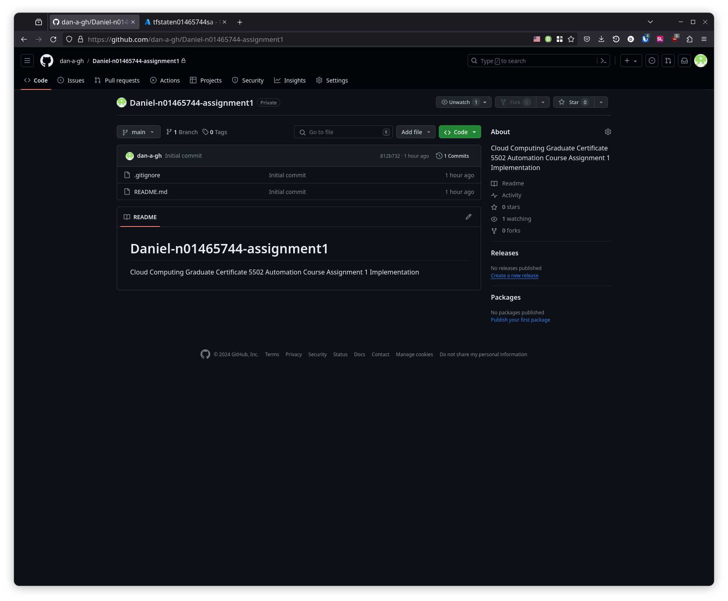

### Cocogitto

Cocogitto is a tool to create conventional commits, which is a standard to help organize git commit messages. It can also manage versioning based on what type of work was identified in the commit messages since the last version was tagged. Since I already had the tool installed, setup involved running the command cog init, and filling out the cog.toml configuration file with commands that use git hooks to run before/after bumping the version number.

SCREENSHOT 2: cog.toml, the configuration file for cocogitto, a conventional commits tool

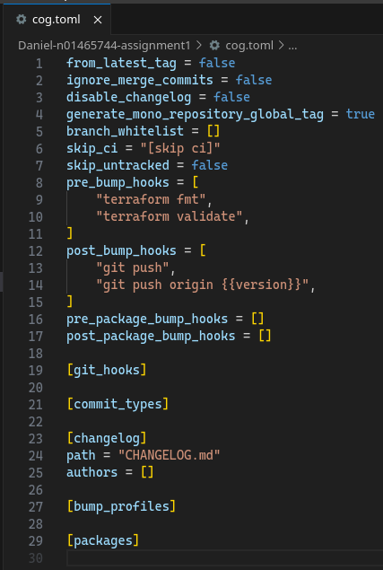

### backend.tf and providers.tf

The backend.tf and providers.tf files were next to be created. I drew heavy inspiration from work performed in lab 05. I changed the name of the key once I realized that it was going to overwrite tfstate from the labs if no changes were made.

SCREENSHOT 3: backend.tf and providers.tf

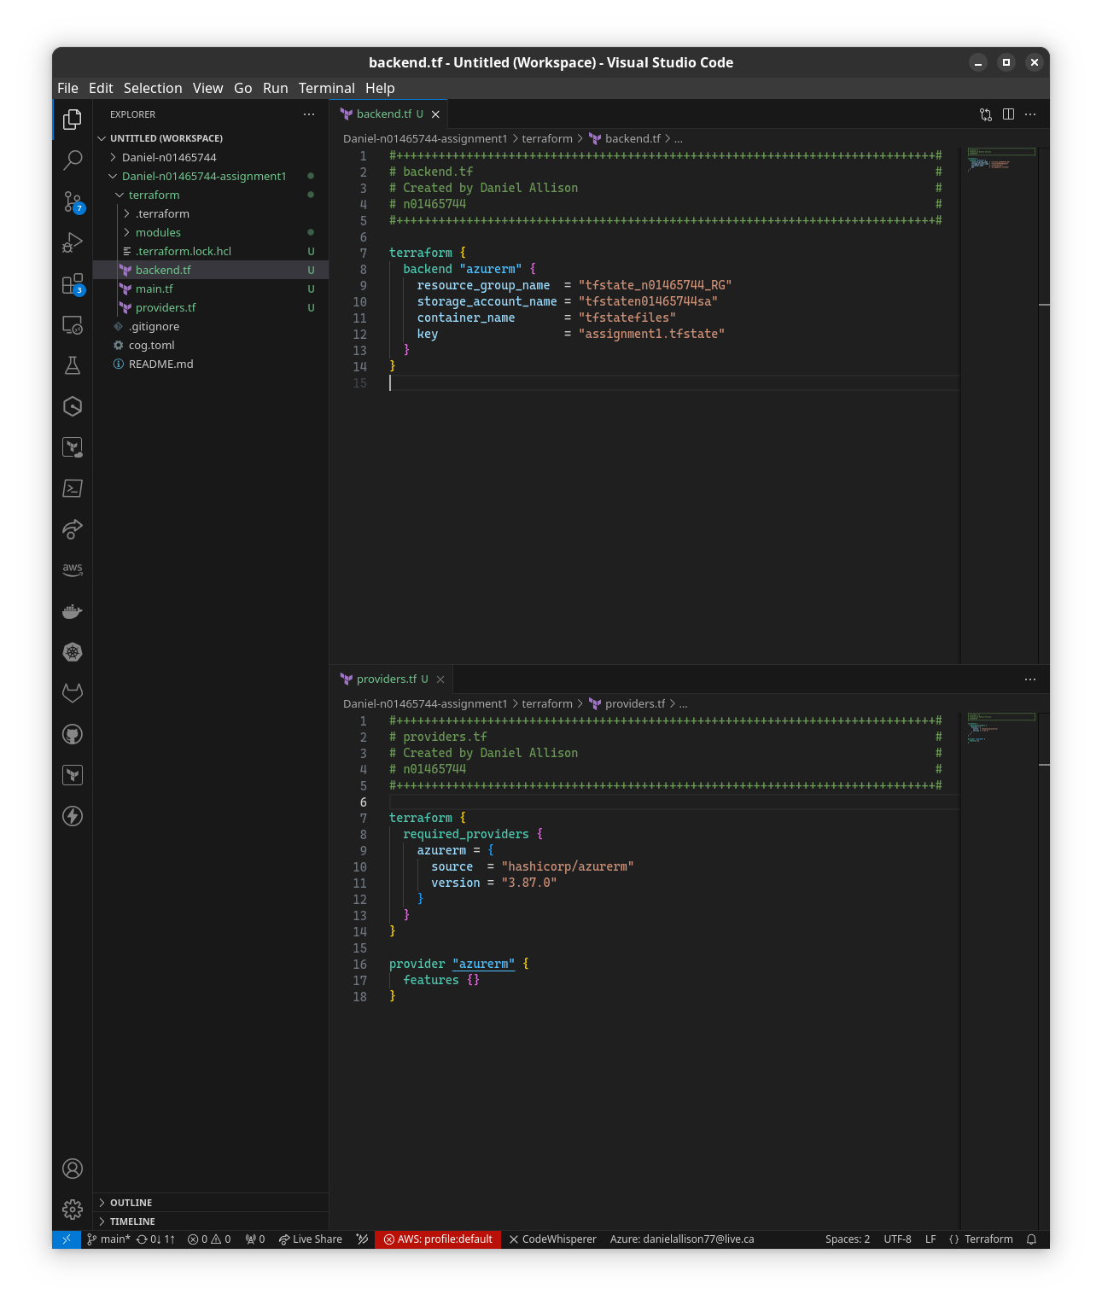

### terraform init

With the bare minimum files in place to initialize, I went ahead and tested my code with terraform init. The first time was with the old key tfstate that would have overwritten the labs work, the second successful time with the migrate state option uses the new backend tfstate key.

SCREENSHOT 4: terraform init and then again with migrate state to the new backend tfstate key

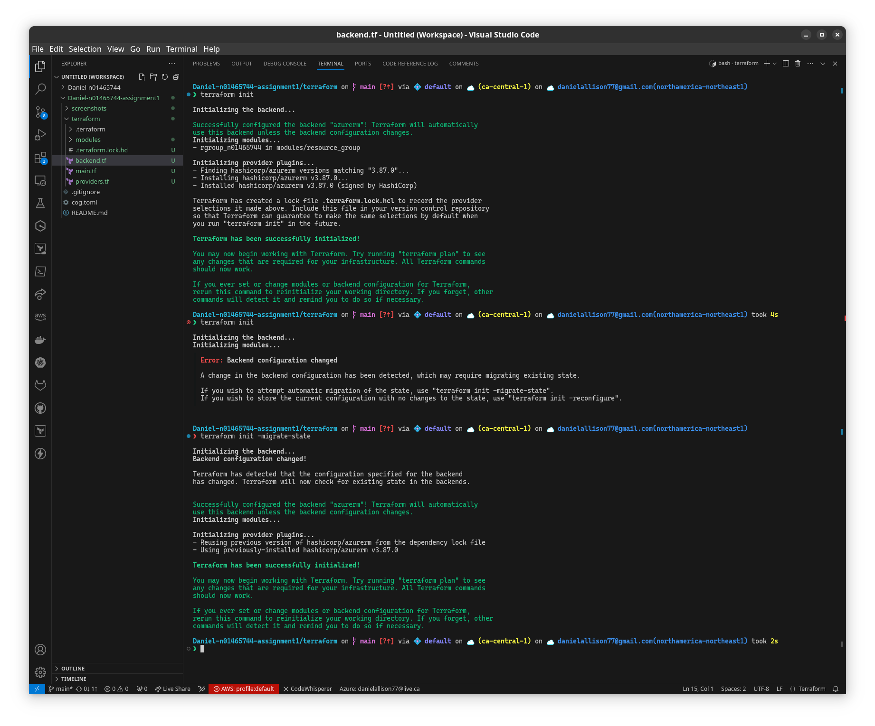

### Project Metadata (root variables.tf)

For the data used in tags common to all resources, I have created a variables.tf at the root level with one object variable called “project_metadata”. I chose this approach over using locals because locals are meant to be used within a module, like a function’s temporary local variables in traditional programming languages.[1]

SCREENSHOT 5: variables.tf in the root module showing the project_metadata variable, used for tagging every resource

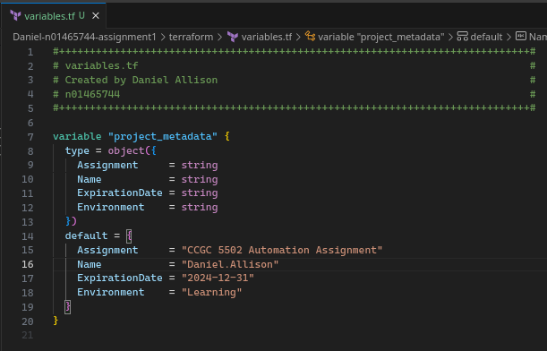

## Resource Group Child Module

### Definition

The resource group resource is defined in main.tf with parametrized fields, tagged with project metadata, corresponding variables are declared in variables.tf, and outputs.tf returns the resource group name.

SCREENSHOT 6: Resource group child module’s main.tf, variables.tf, and outputs.tf

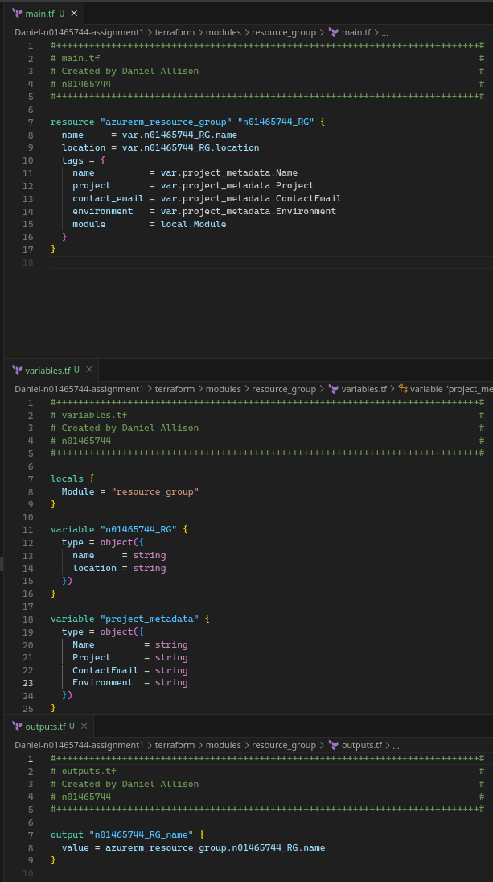

### *Dev Test: Validation, Provisioning, Verifying in Azure Portal*

This module was tested with terraform validate, plan, and deploy.

SCREENSHOT 7: terraform validate shows valid configuration for newly added resource group

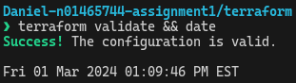

SCREENSHOT 8: terraform state list | nl shows the provisioned resource group



The resource group was verified as provisioned in Azure Portal.

SCREENSHOT 9: Azure Portal shows the assignment1.tfstate after resource group provisioned

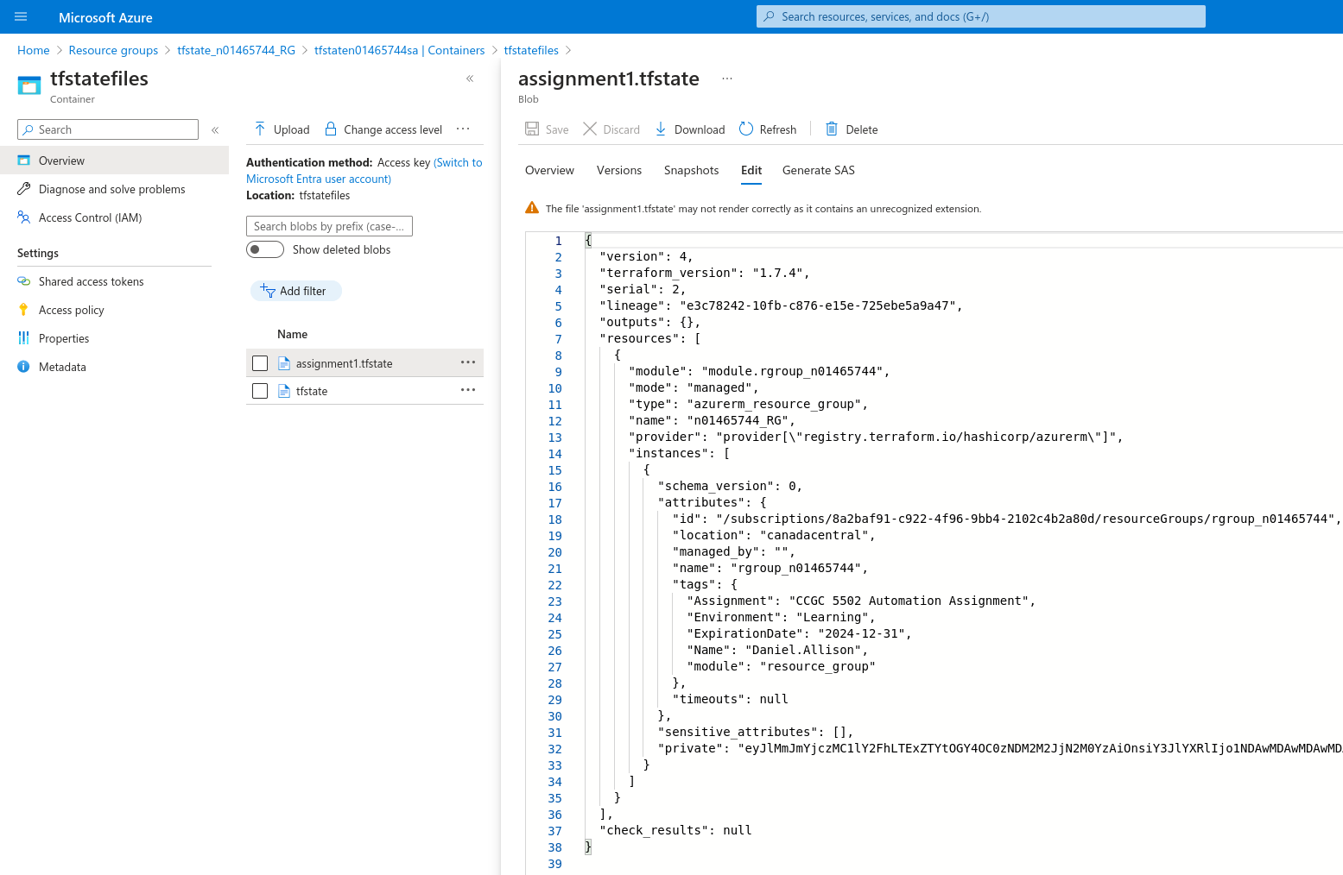

SCREENSHOT 10: Azure Portal shows provisioned resource group with tags

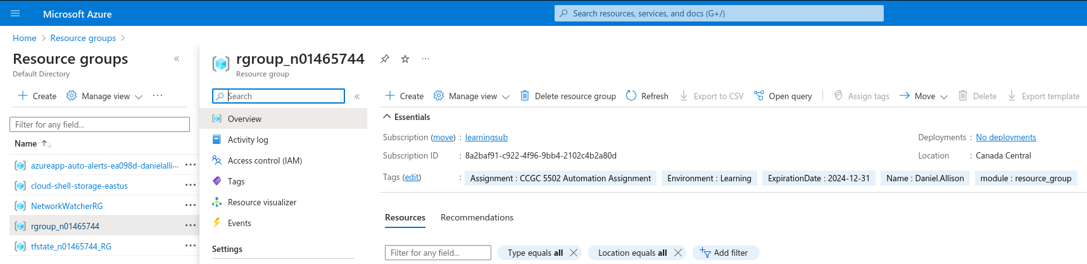

### Release

The resource group child module was released in version 0.1.0.

## Network Child Module

### Definition

The virtual networking, subnet, network security group, network security rule, and subnet network security group association resources are defined in main.tf with parametrized fields, and tagged with project metadata.[2]

SCREENSHOT 11: Network child module's main.tf, with a vnet, subnet, nsg, and net sec rules

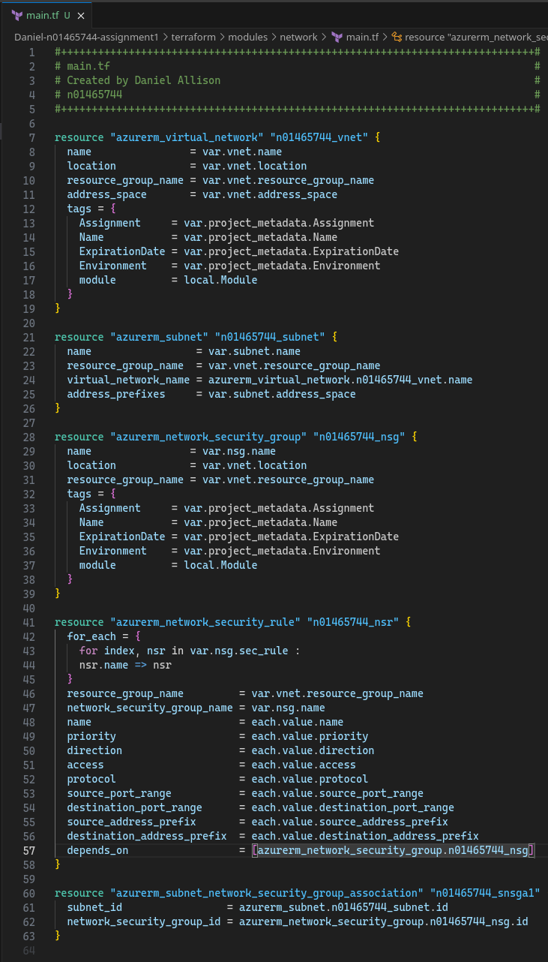

The corresponding variables are declared in variables.tf.

SCREENSHOT 12: Network child module’s variables.tf with variables for vnet, subnet, nsg, local module and project metadata

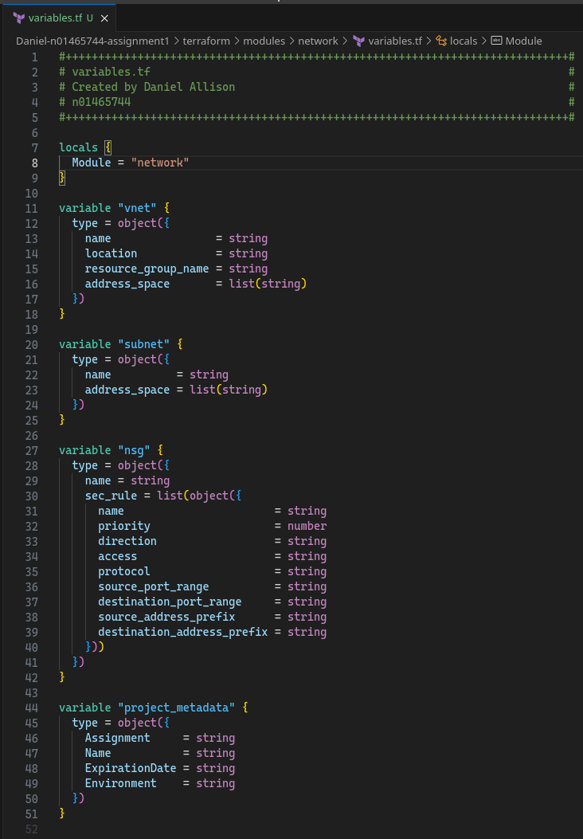

outputs.tf returns the names of the virtual network and subnet to the root module.

SCREENSHOT 13: Network child module's outputs.tf with vnet and subnet names

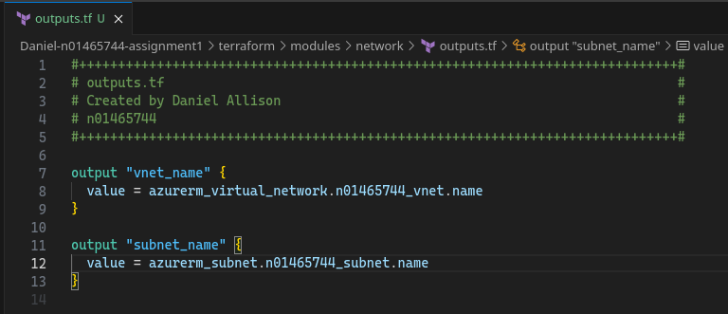

### *Dev Test: Validation, Provisioning, Verifying in Azure Portal*

This module was tested with terraform validate, plan, and deploy.

SCREENSHOT 14: terraform validate shows valid configuration for newly added network module

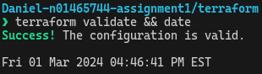

SCREENSHOT 15: terraform state list shows 9 resources provisioned after network module added

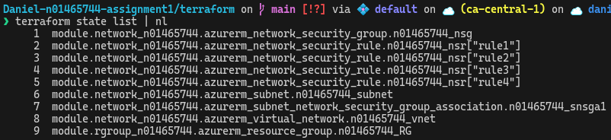

SCREENSHOT 16: Azure Portal shows assignment1.tfstate after network module provisioned

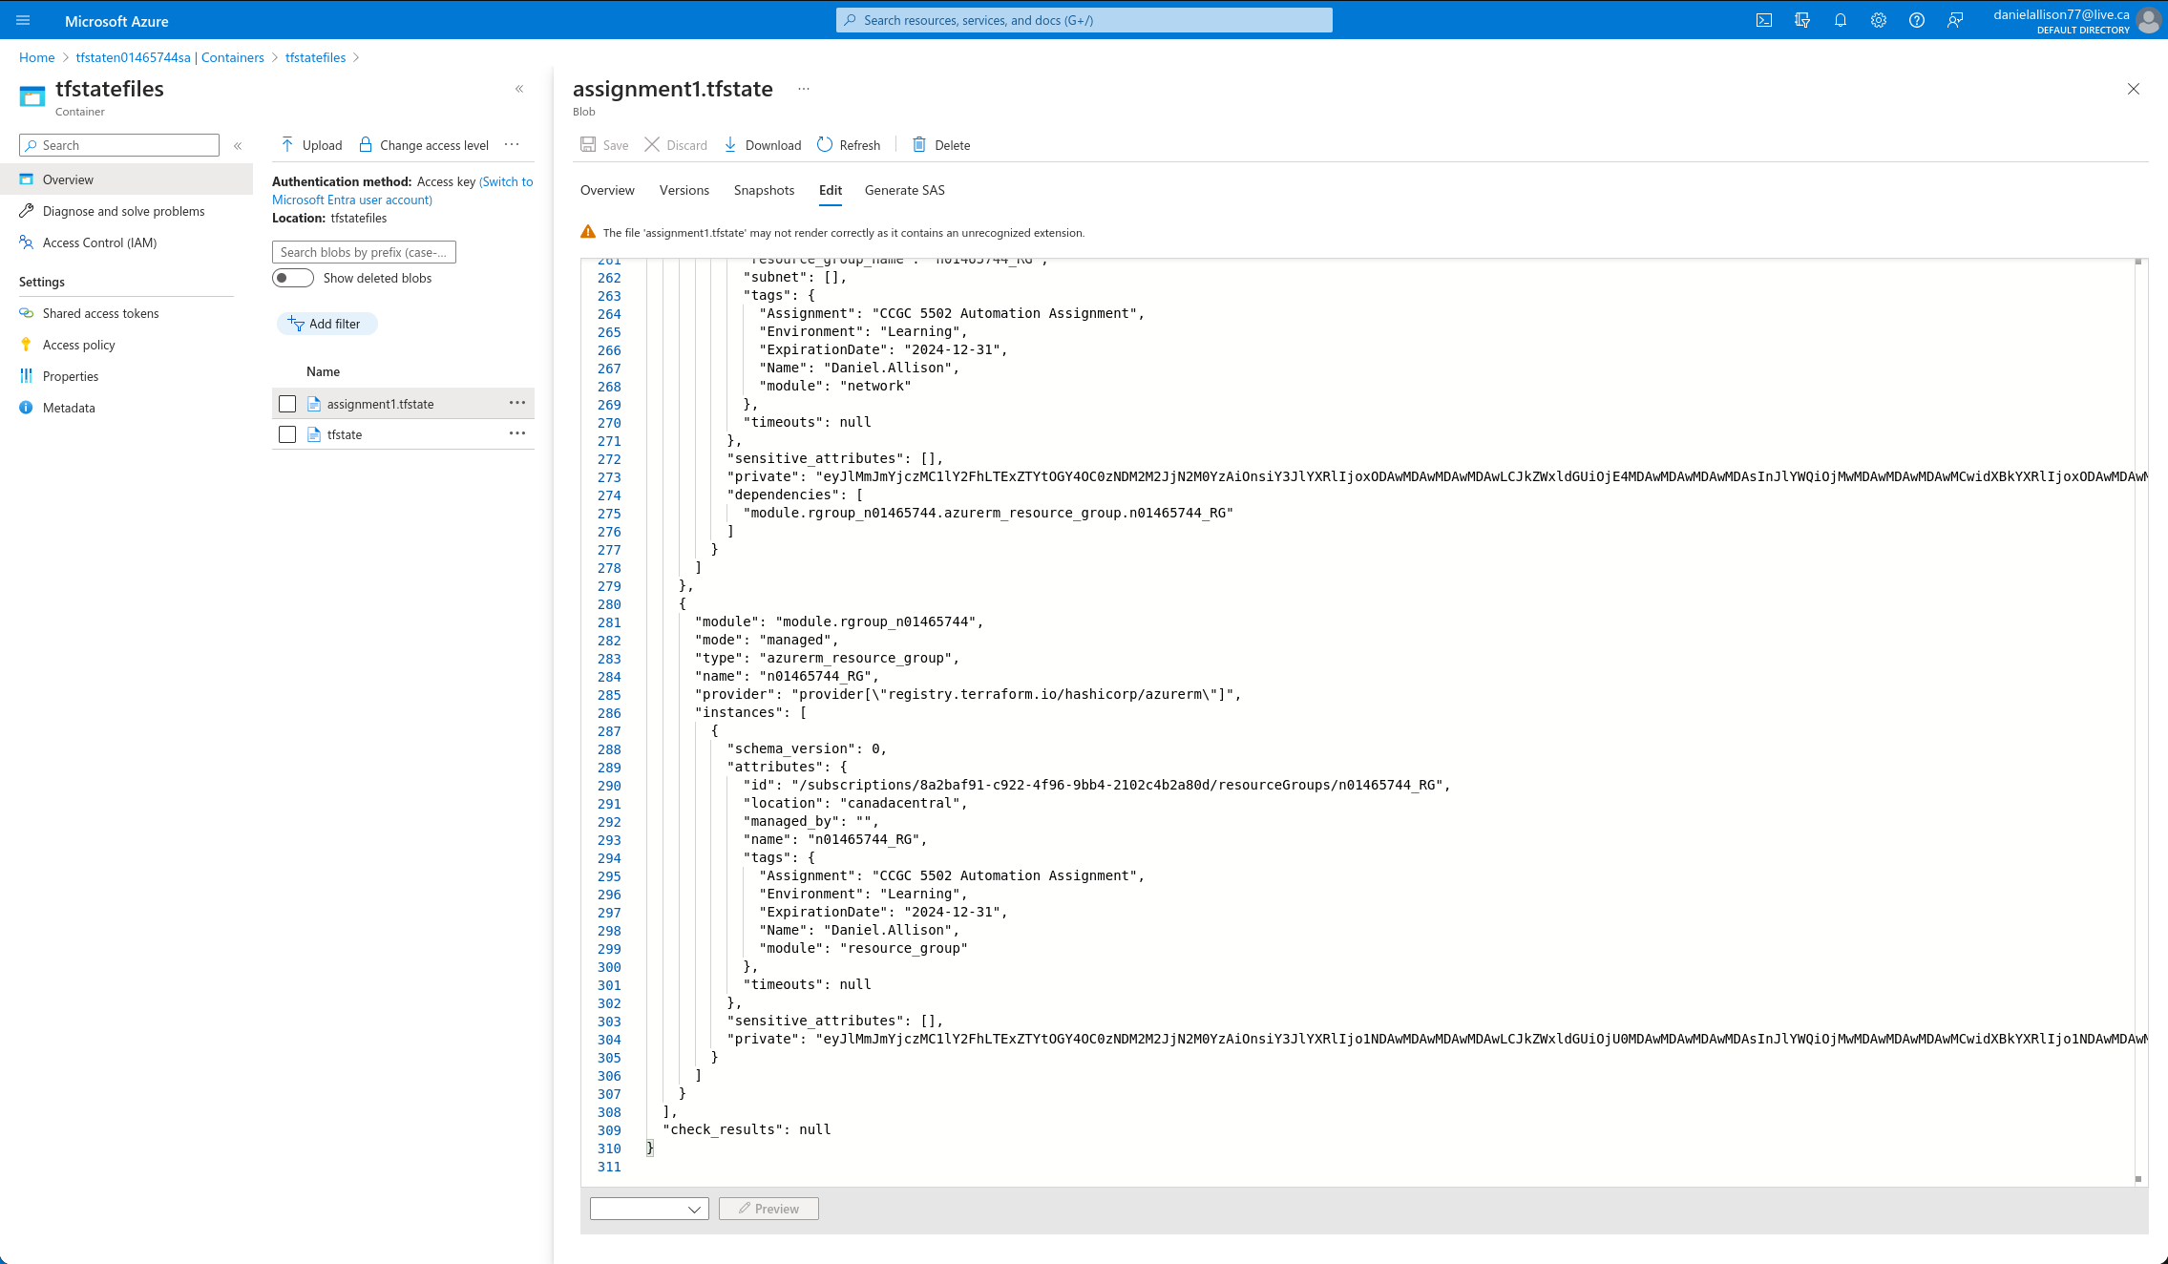

SCREENSHOT 17: Azure Portal shows provisioned network security group with open ports 22, 3389, 5985, and 80

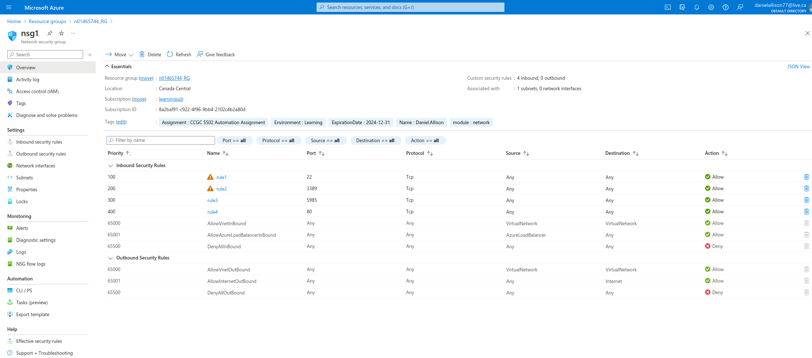

### Release

The network child module was released in version 0.2.0.

## Common Child Module

### Definition

The log analytics workspace, recovery services vault, and storage account are defined in main.tf with parametrized fields, and tagged with project metadata.

SCREENSHOT 18: Common child module's main.tf including log analytics workspace, recovery services vault, and storage account

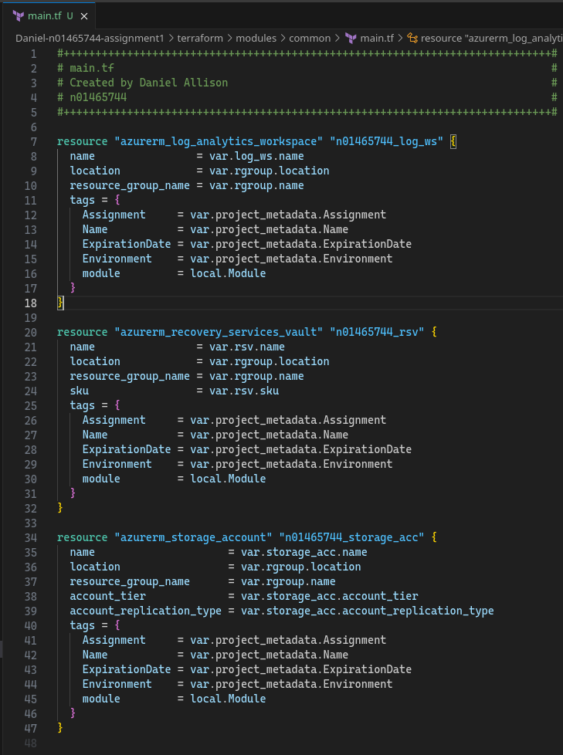

The corresponding variables are declared in variables.tf.

SCREENSHOT 19: Local module variable, variables for resource group, log analytics workspace, recovery services vault, storage account, and project metadata

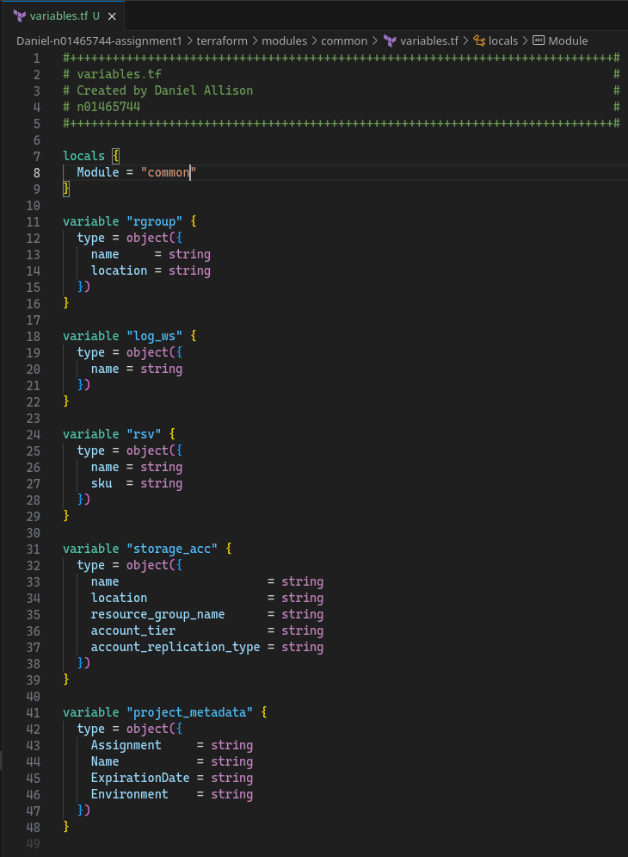

SCREENSHOT 20: Common child module’s outputs.tf returns log analytics workspace name, recovery services vault name, and storage account name

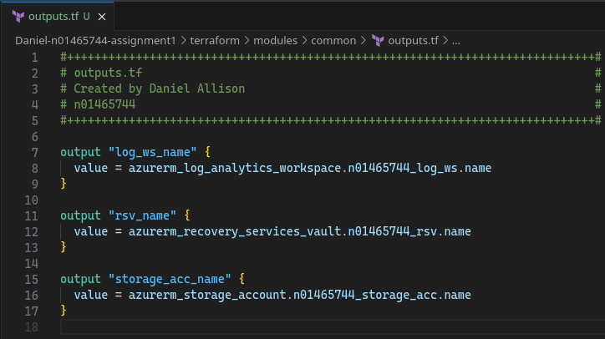

### Dev Test: *Validation, Provisioning, Verifying in Azure Portal*

This module was tested with terraform validate, plan, and deploy.

SCREENSHOT 21: terraform validate shows valid configuration for newly added common module

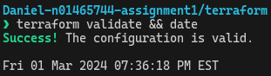

SCREENSHOT 22: terraform state list | nl shows 12 provisioned resources including newly added log analytics workspace, recovery services vault, and storage account

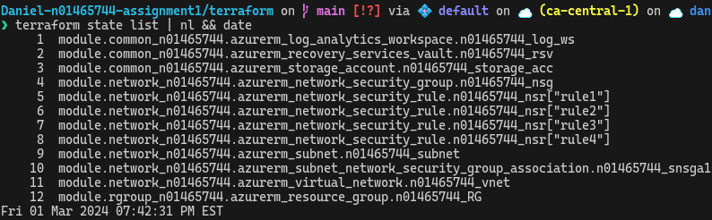

SCREENSHOT 23: Azure Portal shows assignment1.tfstate showing the last lines of provisioned resources

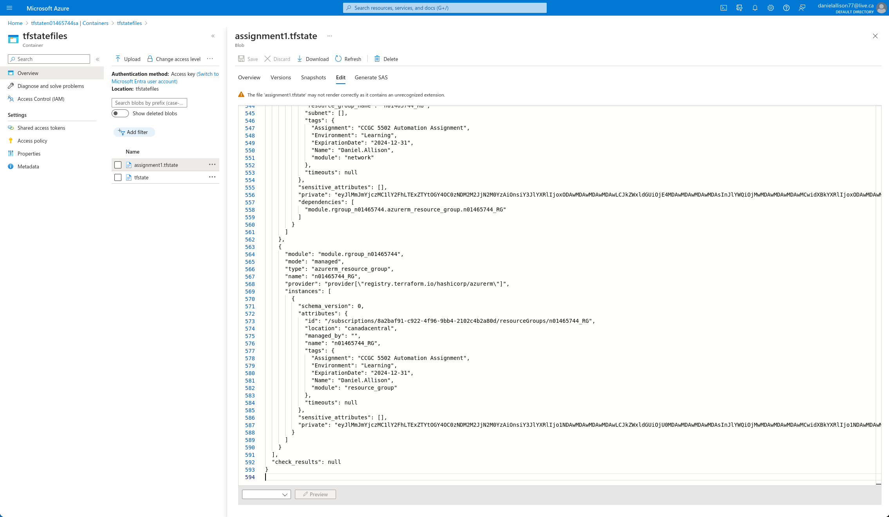

### Release

The common child module was released in version 0.3.0.

## Linux Child Module

### Research

In order to deploy a CentOS virtual machine, a suitable offering needed to be found from the Azure Marketplace. Microsoft maintains a list of endorsed Linux distributions[3], which is a good place to start to look for CentOS offering. OpenLogic by Perforce, formerly RogueWave, maintains several images. Using the following PowerShell command in Azure Cloud Shell, two candidates were identified:

SCREENSHOT 24: Azure Cloud Shell shows a PowerShell command that identifies CentOS 8.2 offerings from OpenLogic



8_2-gen2 was picked. This next command identified the version number of the latest version:

SCREENSHOT 25: Azure Cloud Shell shows a PowerShell command that identifies the version number for CentOs 8_2-gen2



The virtual machine extensions required some extra care to figure out an acceptable value for the type_handler_version. The following PowerShell commands were run[4] in Azure Cloud Shell to find information about the latest versions of the Monitor and Network Watch extensions.

SCREENSHOT 26: Azure Cloud Shell shows PowerShell commands being run to find out the virtual machine extensions' types, versions, and publisher

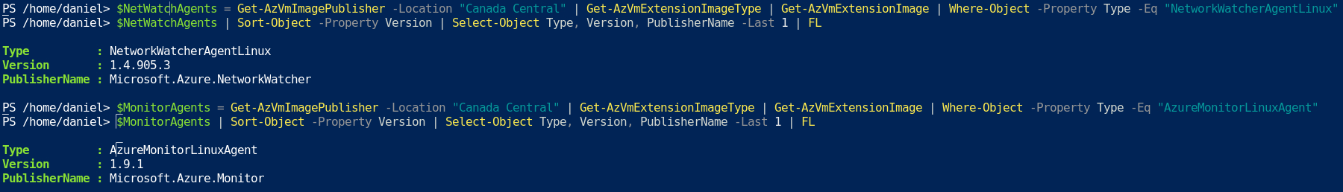

Terraform won’t accept those version numbers unmodified though. They must be truncated to major.minor only.[5] This was not clear in the terraform documentation.[6]

### Definition

SCREENSHOT 27: Linux child module's main.tf, lines 1-64

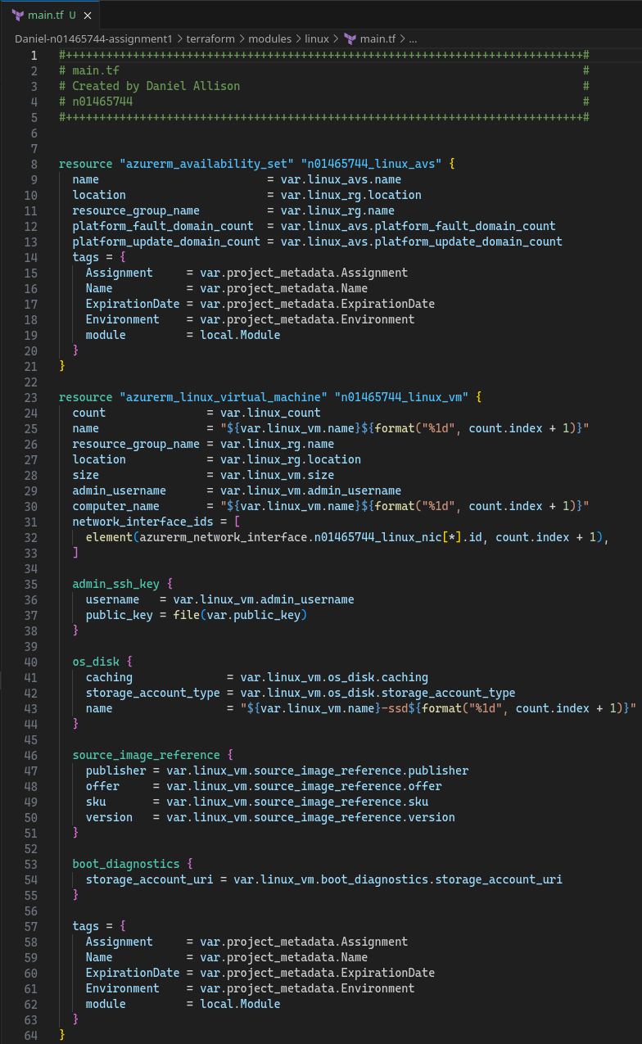

SCREENSHOT 28: Linux child module's main.tf, lines 65-118

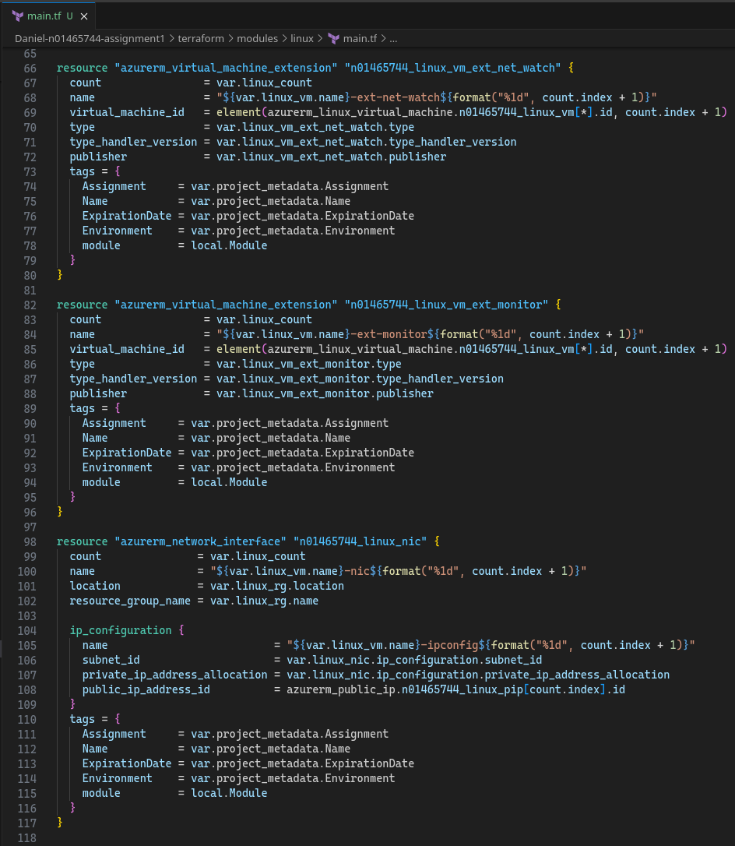

SCREENSHOT 29: Linux child module's main.tf, lines 118-134

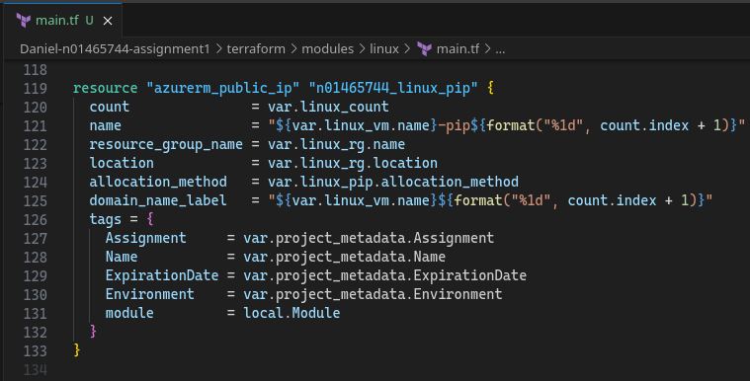

SCREENSHOT 30: Linux child module's variables.tf, lines 1-66

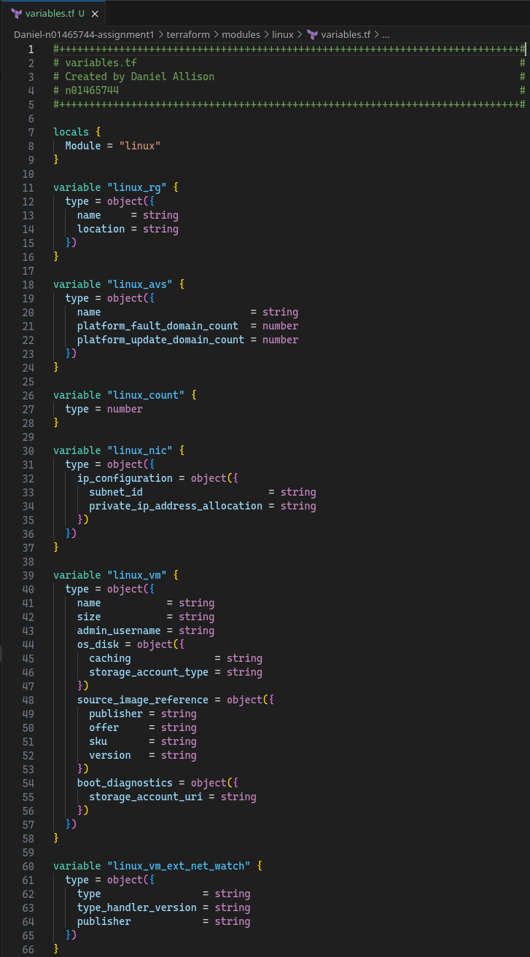

SCREENSHOT 31: Linux child module's variables.tf lines 67-108

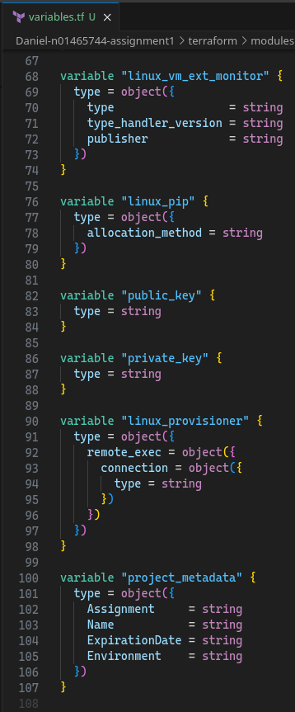

SCREENSHOT 32: Linux child module's outputs.tf

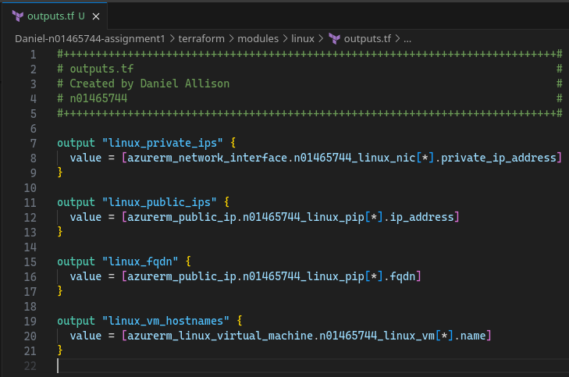

SCREENSHOT 33: Linux child module's provisioner.tf

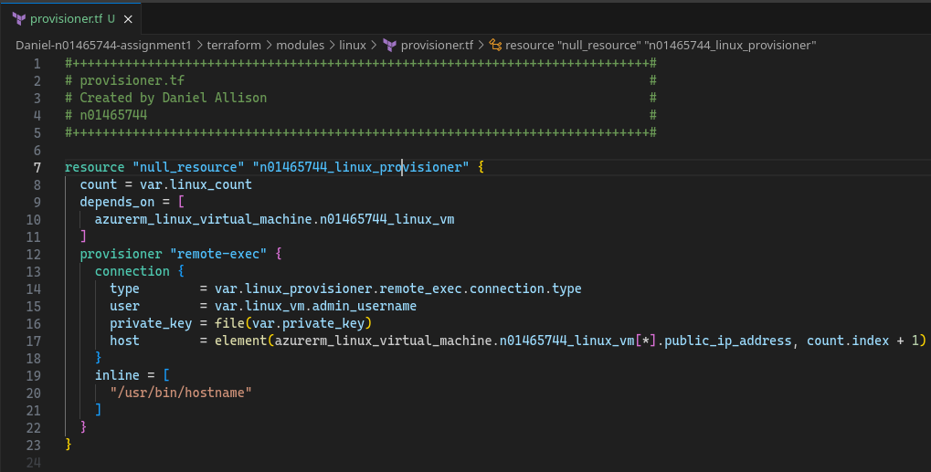

### Dev Test: *Validation, Provisioning, Verifying in Azure Portal*

This module was tested with terraform validate, plan, and deploy.

SCREENSHOT 34: terraform validate shows configuration is valid after Linux child module added

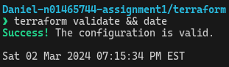

SCREENSHOT 35: terraform state list | nl shows 25 provisioned resources after Linux module added

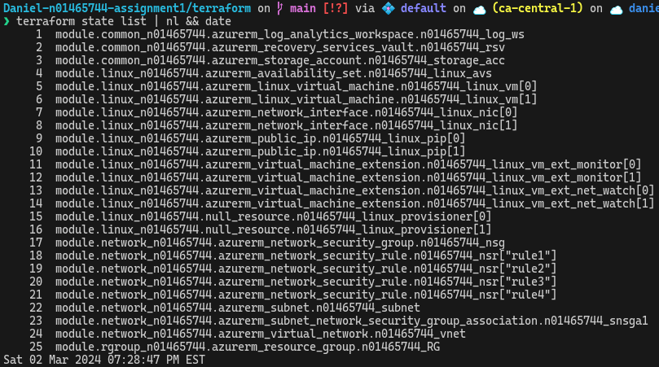

SCREENSHOT 36: Azure Portal shows provisioned resources after Linux module added

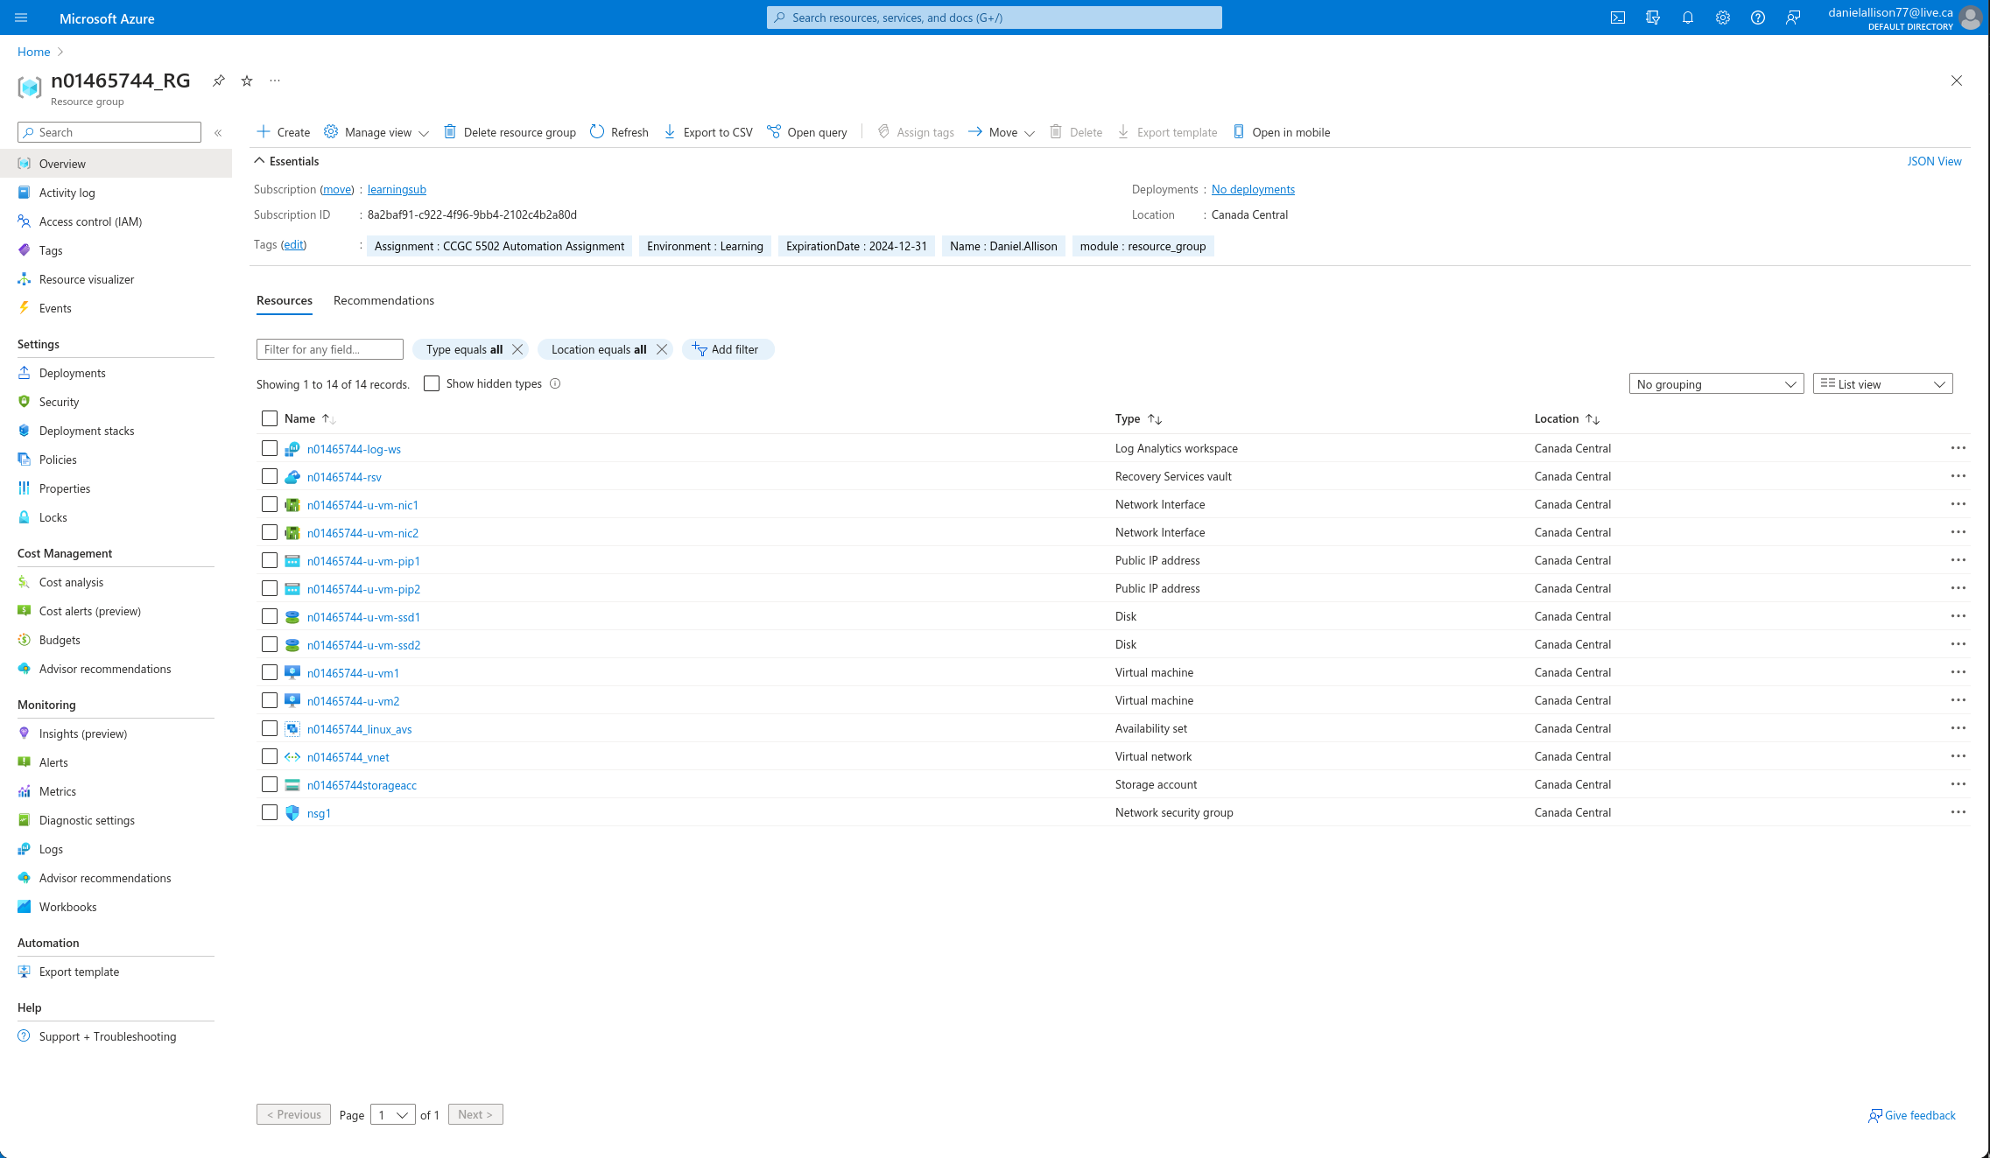

### Release

The Linux child module was released in version 0.4.0.

## Windows Child Module

### Research

The following PowerShell commands were run[7] in Azure Cloud Shell to find information about the latest versions of the antimalware extension.

SCREENSHOT 37: Azure Cloud Shell shows a PowerShell commands used to find the details of the antimalware vm extension

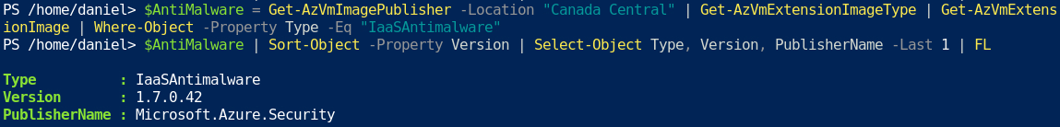

### Securing Credentials

User credentials should not be directly stored in Terraform code. To secure them, a new Azure Key Vault was created in it’s own separate resource group. The az cli tool was used for this purpose[8]:

SCREENSHOT 38: Az cli is used to create a new resource group for a new key vault

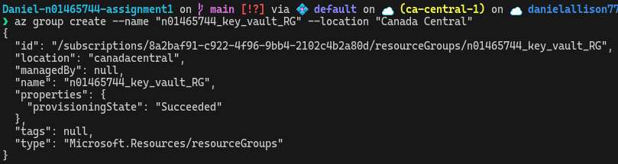

SCREENSHOT 39: Az cli is used to create a new key vault

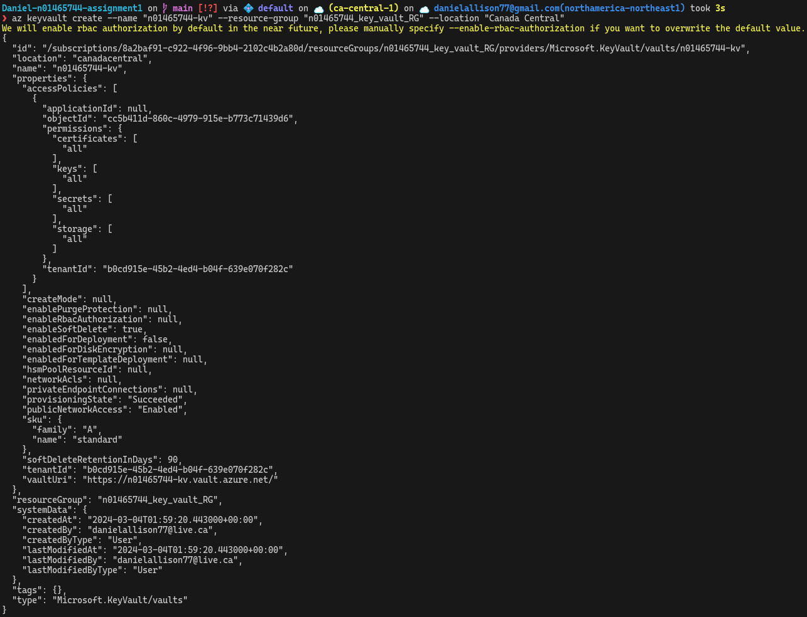

SCREENSHOT 40: Az cli is used to store a secret, the Windows admin password

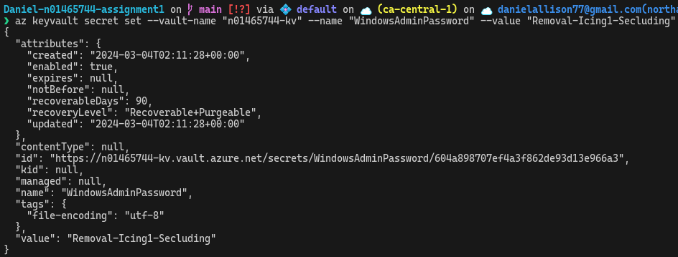

### *Definition*

SCREENSHOT 41: Windows child module's main.tf, lines 1-62

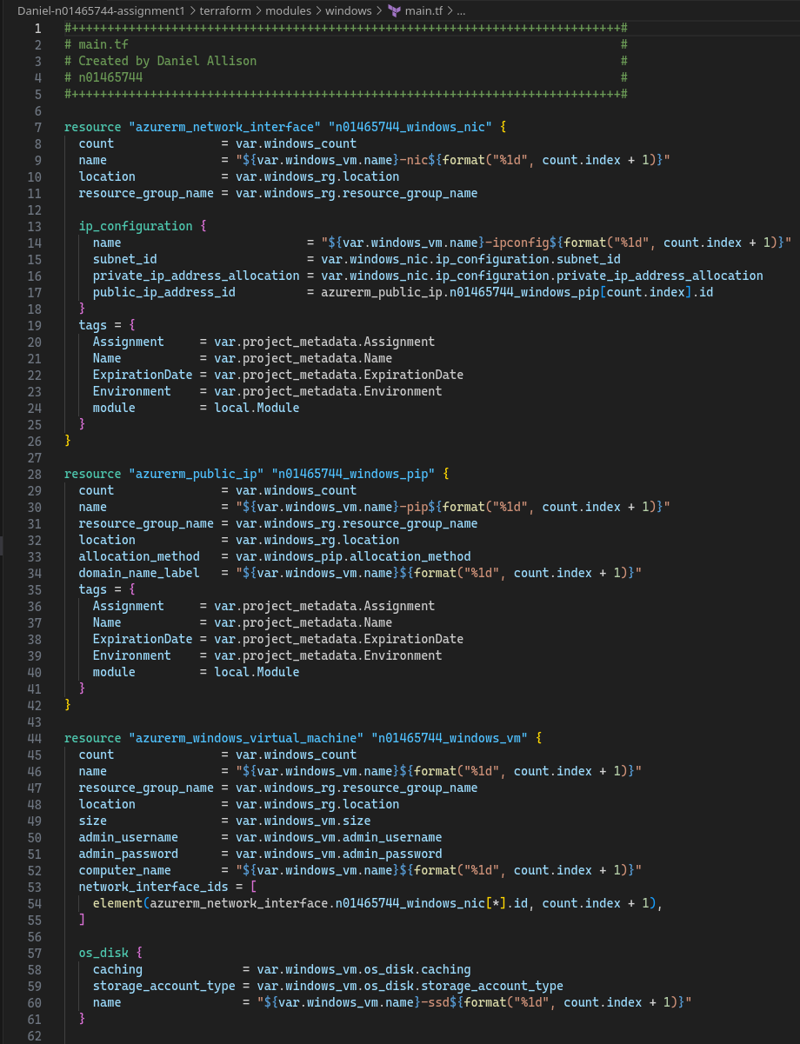

SCREENSHOT 42: Windows child module's main.tf, lines 62-112

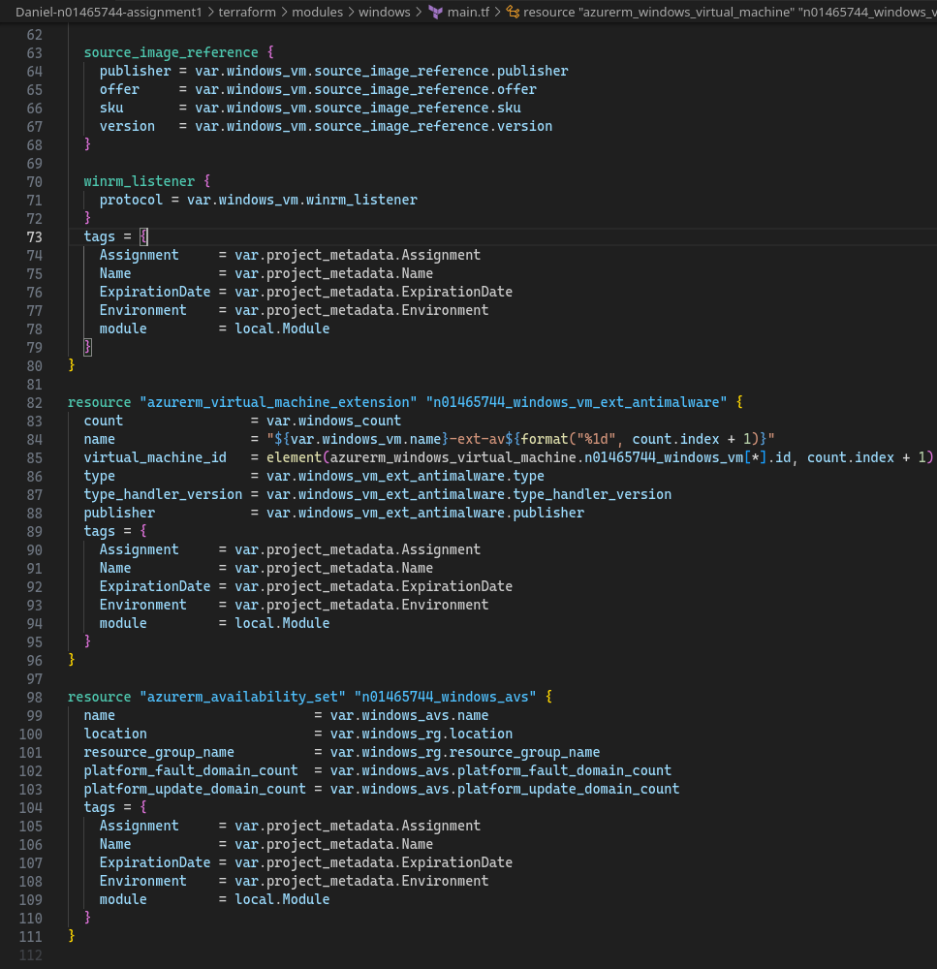

SCREENSHOT 43: Windows child module's variables.tf, lines 1-60

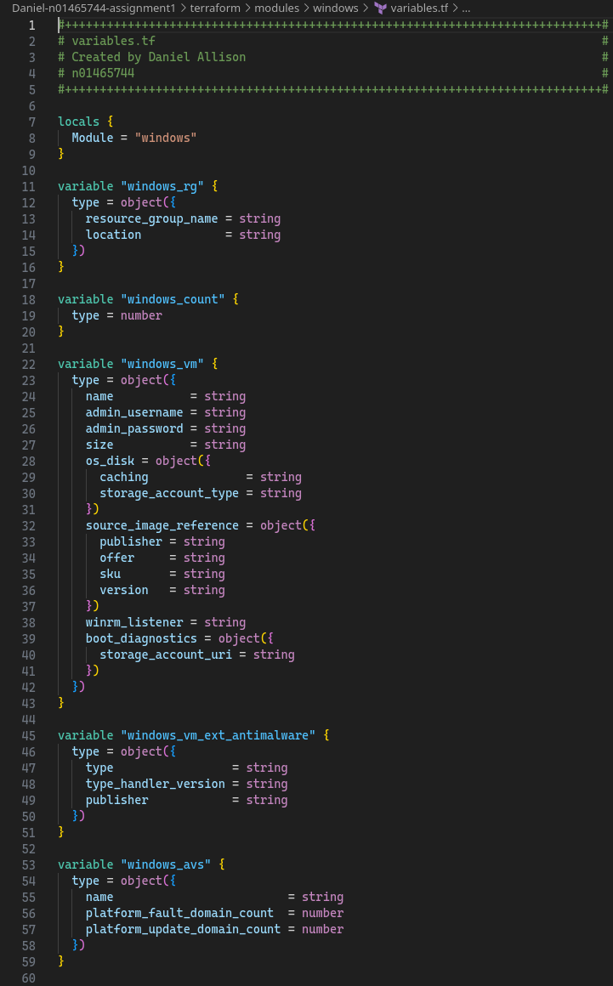

SCREENSHOT 44: Windows child module's variables.tf, lines 60-84

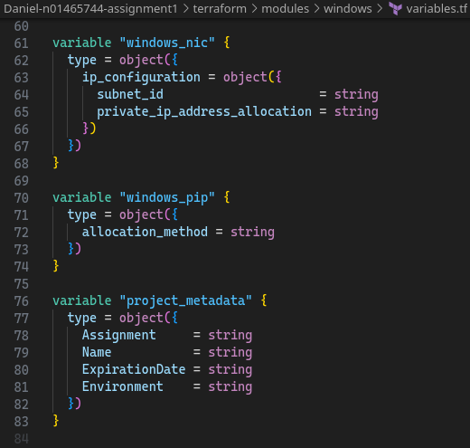

SCREENSHOT 45: Windows child module's outputs.tf

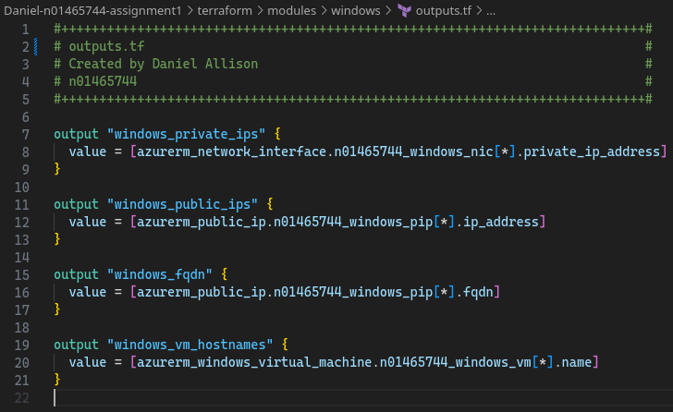

### *Dev Test: Validation, Provisioning, Verifying in Azure Portal*

This module was tested with terraform validate, plan, and deploy.

SCREENSHOT 46: terraform validate shows configuration is valid after Windows module added

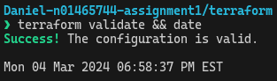

SCREENSHOT 47: terraform state list shows provisioned resources

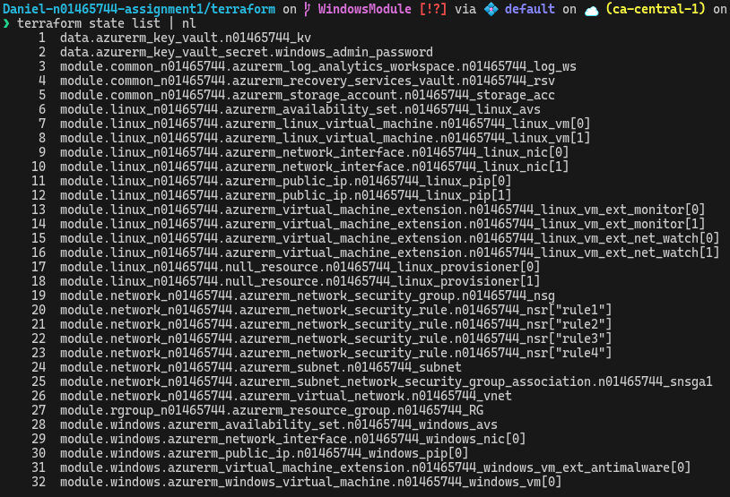

SCREENSHOT 48: Azure Portal shows all provisioned resources, including the newly added ones from the Windows child module

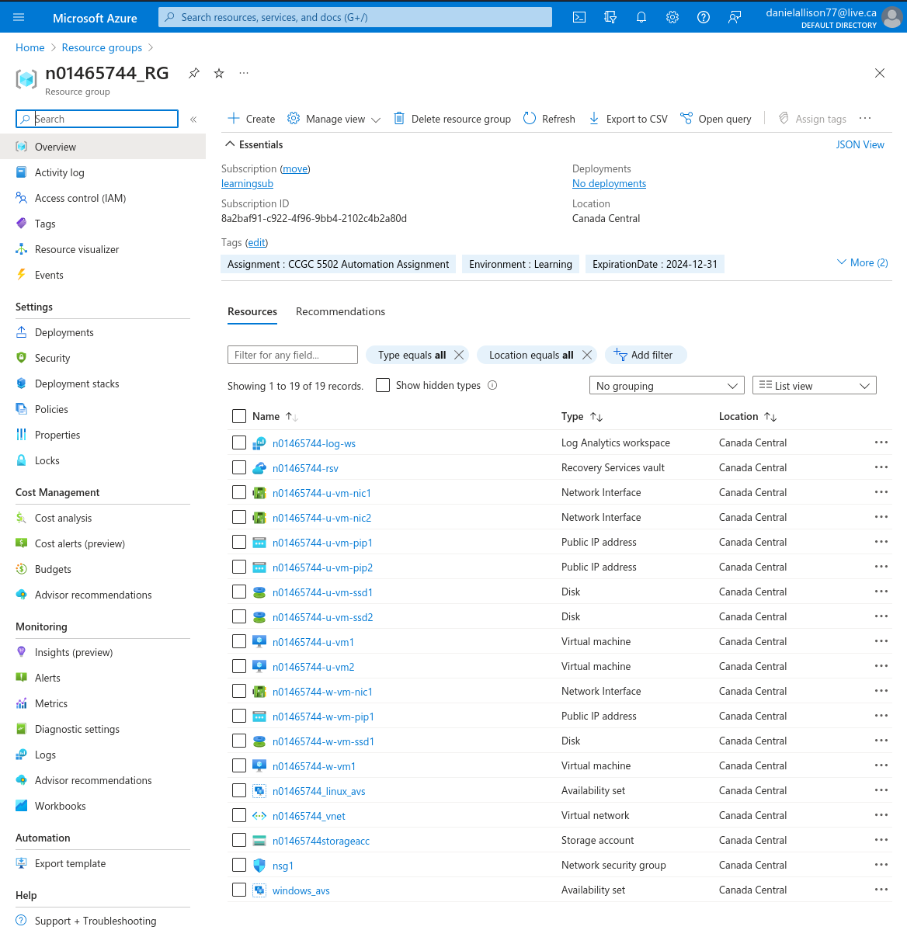

SCREENSHOT 49: Azure Portal shows provisioned Windows VM with antimalware extension

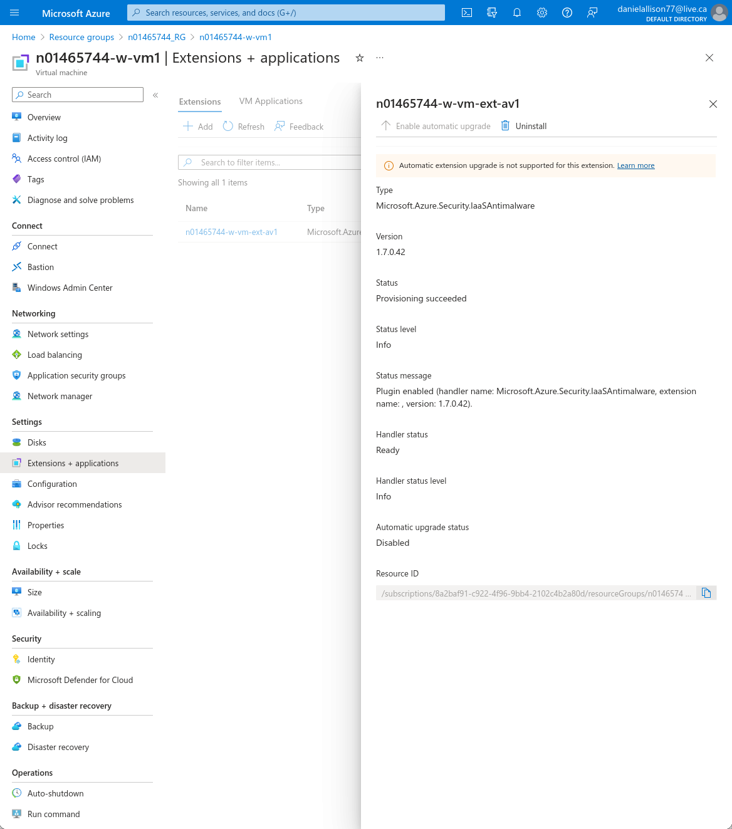

### Release

The Windows child module was released in version 0.5.0.

## Data Disks Child Module

### Definition

This module required some changes in previous modules. The full code can be viewed in the Github repository. In the windows and linux child modules, 2 new output variables were added to their respective outputs.tf for linux_vm_ids and windows_vm_ids.

SCREENSHOT 50: linux child module's outputs.tf, new output variable linux_vm_ids

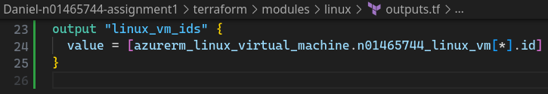

SCREENSHOT 51: window's child module's outputs.tf, new output variable windows_vm_ids

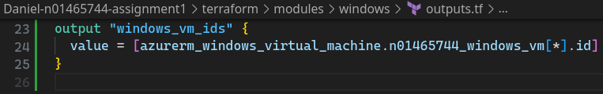

These lists were concatenated and the result flattened to make one list of vm ids in the root module’s local variables. The same process was done for hostnames.

SCREENSHOT 52: root module's variables.tf, with newly added locals for vm_hostnames and vm_ids

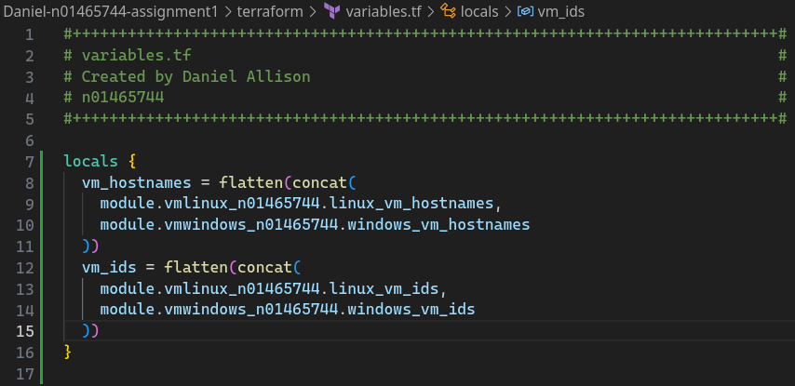

These lists were then ran through the zipmap function to create a variable called virtual_machines.

SCREENSHOT 53: data disk child module's main.tf

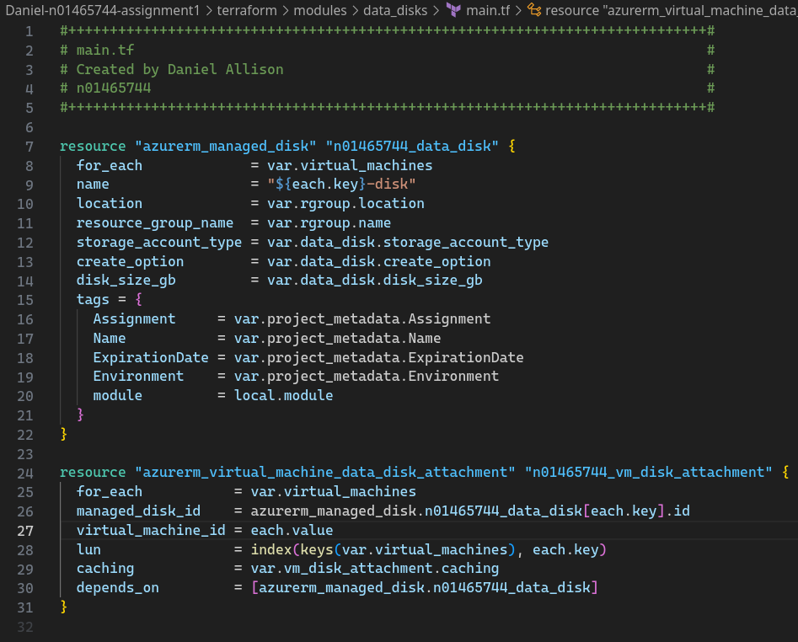

SCREENSHOT 54: data disks child module's variables.tf

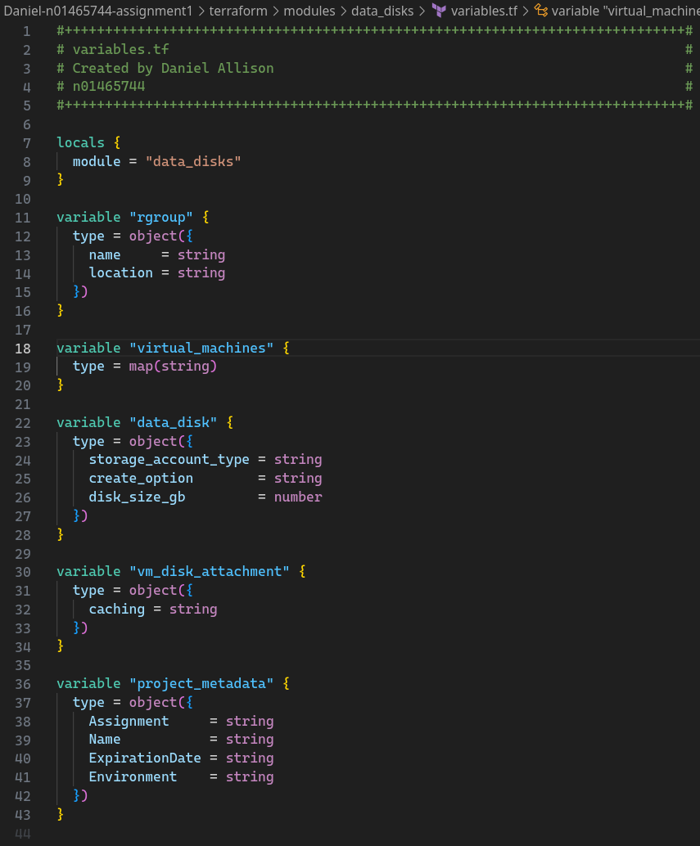

### *Dev Test: Validation, Provisioning, Verifying in Azure Portal*

SCREENSHOT 55: terraform validate shows valid configuration after data disk module added

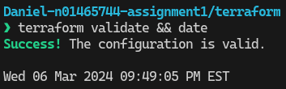

SCREENSHOT 56: terraform state list | nl shows 38 provisioned resources

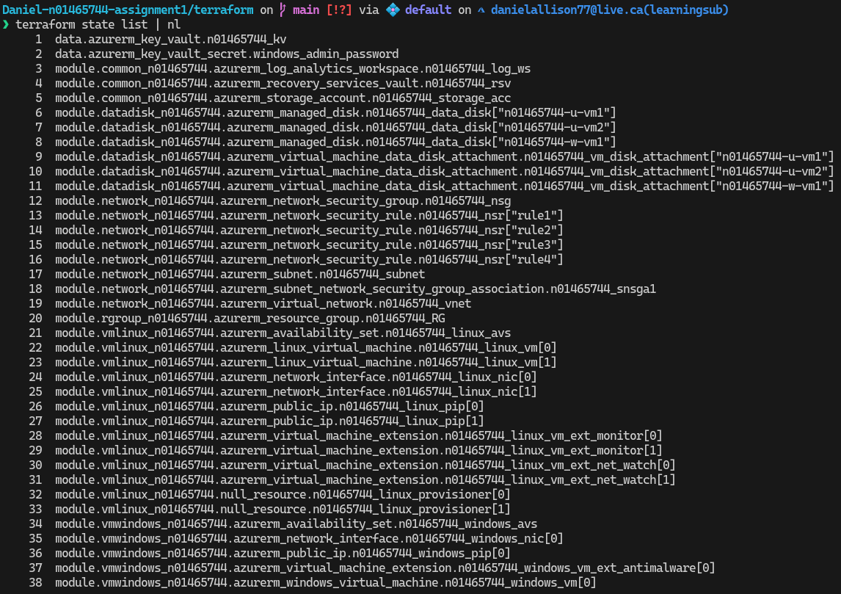

SCREENSHOT 57: Azure Portal shows data disks

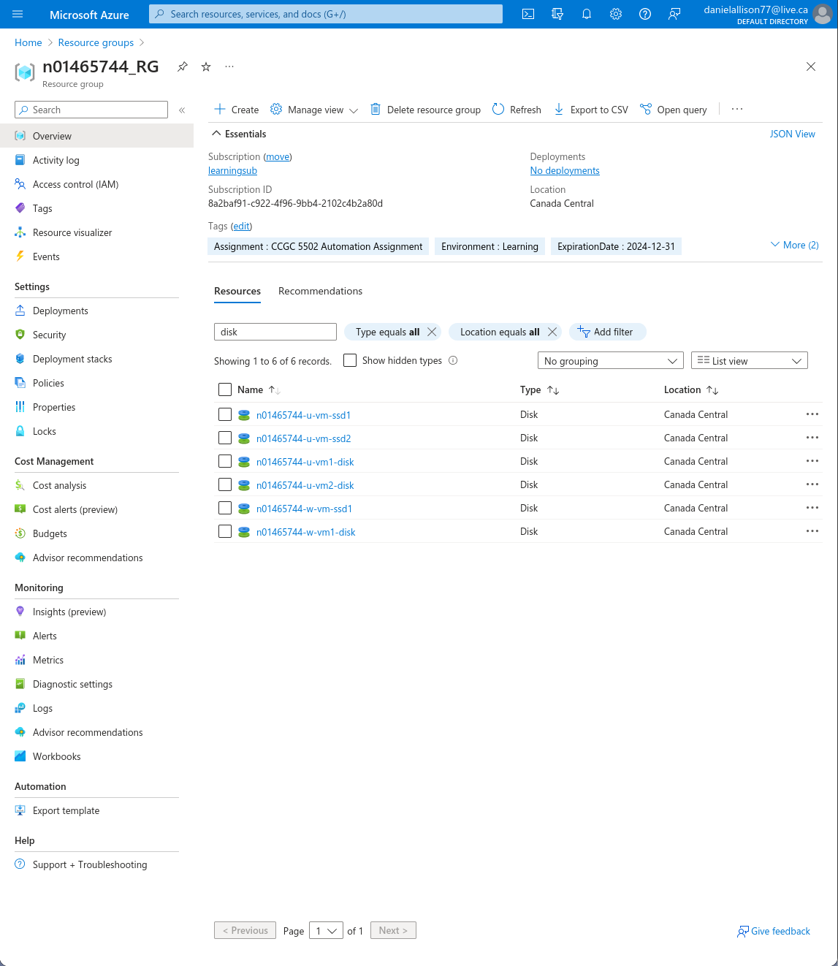

SCREENSHOT 58: Azure Portal shows one of the data disks associated with a Linux VM

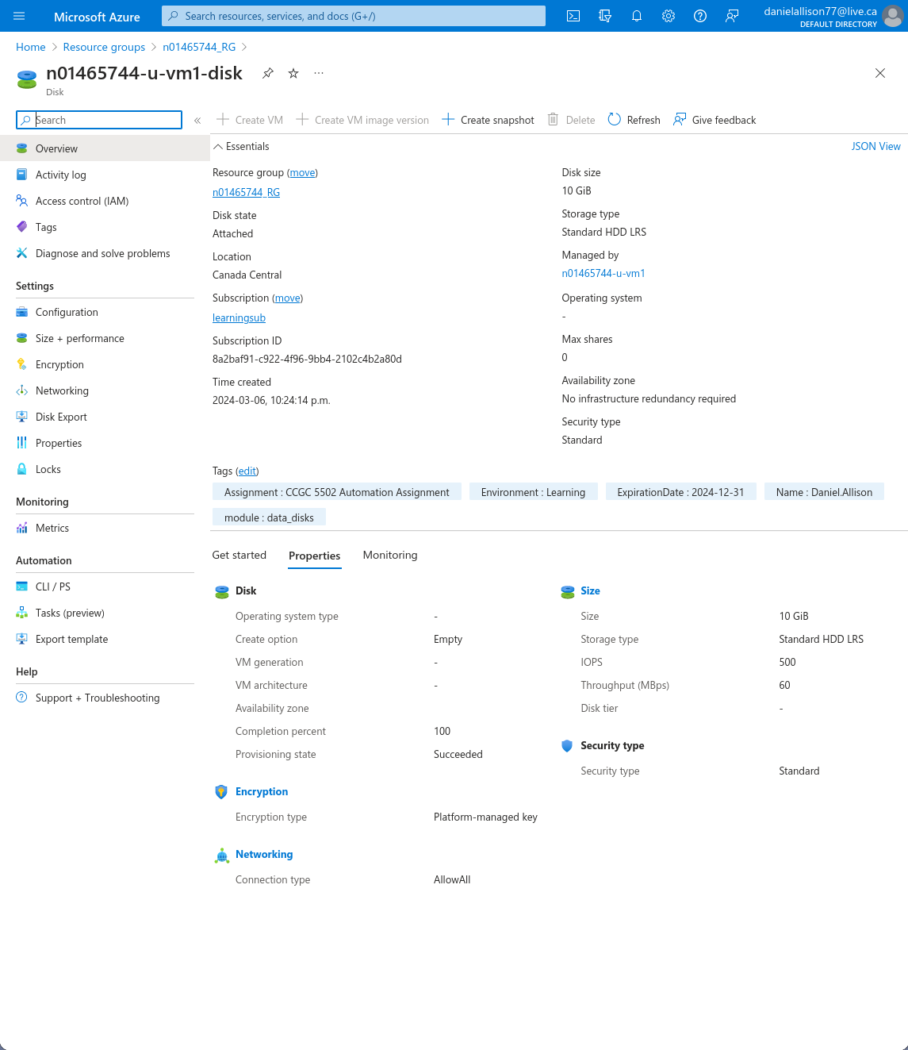

### Release

The Windows child module was released in version 0.6.0.

1. https://developer.hashicorp.com/terraform/language/values/locals
2. Inspiration for for_each iterating over objects taken from this StackOverflow answer: https://stackoverflow.com/a/67871267
3. https://learn.microsoft.com/en-us/azure/virtual-machines/Linux/endorsed-distros
4. https://learn.microsoft.com/en-us/azure/virtual-machines/extensions/features-Windows
5. https://github.com/hashicorp/terraform-provider-azurestack/issues/125
6. https://registry.terraform.io/providers/hashicorp/azurerm/latest/docs/resources/virtual_machine_extension#type_handler_version
7. https://learn.microsoft.com/en-us/azure/virtual-machines/extensions/features-Windows
8. Commands sourced from https://learn.microsoft.com/en-us/azure/key-vault/secrets/quick-create-cli?source=recommendations